**BACKGROUND ARTICLE**

**Proactive risk management in material procurement in times of a pandemic**

Dr. Philipp Ponton, Vice President Global Procurement Aenova Group

The pandemic triggered by COVID-19 has a major impact worldwide. As a result, all branches of industry are faced with various challenges.

As a leading contract manufacturer (CDMO) for numerous pharmaceutical companies, the Aenova Group is an important part of the value chain in the pharmaceutical industry and is primarily confronted with the issue of always ensuring the supply of patients with partly vital drugs.

During the first phase of the COVID-19 pandemic in spring 2020, it became clear to many industries that the challenges of globalization and the relocation of raw material production to Asia had been accepted, if not ignored, for many years.

The special problem within the pharmaceutical industry is that, on the one hand, the active ingredients are either only available in Asia or - if they are produced in Europe - the intermediates are often of Asian origin.

An additional challenge is that in the highly regulated pharmaceutical market, many dossiers only allow for one source of raw materials, which further exacerbates the situation.

In order to master this stress test for the supply chain and to ensure that supplies run as smoothly as possible, proactive risk management and permanent communication with all stakeholders, both internal and external, is essential.

**Creating transparency**

Creating a transparent end-to-end view of a complex multi-stage supply chain starts with the first step of identifying critical materials and the main reasons for their criticality. A distinction should be made between direct and indirect materials.

Affected indirect materials are mainly PPA articles (personal protection accessories), such as masks, gloves, etc. Here, during the first wave of the pandemic, availability was the main driver due to exploding demand and cost.

Direct materials are all raw materials like active ingredients, auxiliary materials, etc. and packaging materials.

The drivers for the procurement risk with the direct materials are the place of production for both the raw material and the preliminary products (so called intermediates), how high the local infection occurrence is (in the actual pandemic, the current status of the COVID-19 risk area), the number of alternative procurement sources and their location, the status of the stocks in the creation of value chain and the demand situation of the customers. In this context Aenova developed a **risk index analysis on material level.**

Furthermore, the relevant suppliers and subcontractors must be illuminated: Drivers for supplier risk are the current situation and the probability of a factory closure, capacity availability, supplier risk management, credit status, etc. This resulted in a **risk index analysis at supplier level**.

In addition, the risk factors that specifically occur in a pandemic are added: These are mainly factors that are difficult to influence and constantly changing, such as export regulations for certain raw materials, travel restrictions, border closures, availability of means of transport, etc. This resulted in a **risk index analysis based on pandemic considerations.**

As a result, these three risk indices were combined, a specific risk profile was derived from them and presented in a risk-based overview.

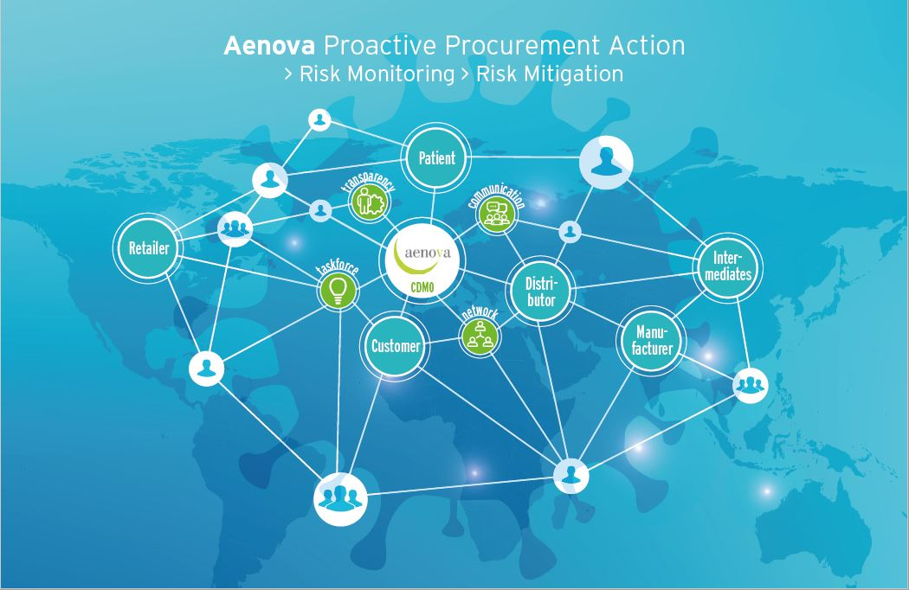

(Aenova_Global_Supply_Chain.jpeg. Graphic Aenova)

**Derive and track measures and established supplier networks**

Based on the risk indices we at Aenova have developed a risk tracking tool. In this tool the risks are continuously evaluated, risk effects are estimated, measures for remedy are defined and the control of the individual risk is evaluated and monitored.

This approach allows to visualize and communicate the problems and solutions in a transparent and timely manner during the pandemic and to make quick decisions.

For the visualization of the process a traffic light logic was established, which divides the risks into three levels - red, yellow and green.

Green: Risk identified and measures initiated to avert risk.

Yellow: Risk is already advanced, but effects can still be minimized or managed by replanning so that there is no "business impact".

Red: The risk has occurred and efforts must be made to reduce the damage.

An important component for the implementation, communication and accuracy of information is digital support by systems and the associated creation of a "source of truth".

In the resulting risk tracking tool, the raw materials and packaging materials concerned are listed. For each risk material, the information described above, such as specification, single source status, possible alternative sources, expected delivery time, affected customers, etc. will be included. Furthermore, the exact facts of the risk are described and evaluated and measures are derived and implemented.

Due to the high volatility during the pandemic, risks and measures are tracked daily to enable an immediate response to constantly changing situations.

**Lessons Learned**

CDMOs depend on a large and complex global supply chain. The pandemic has highlighted were supply chains are at greater risk of being disrupted. Our "lessons learned" can be divided into external, industry-specific and internal learning effects.

In terms of external learning effects, the focus is on the obvious dependence on raw material sources, especially in Asia. Here, the political and strategic decision must be made to ensure that the production of vital raw materials is once again carried out in Europe. Another important point is the high proportion of single-source suppliers in a highly regulated environment. Here the identification and approval of alternative resources is fundamental.

Internally, the lessons learned and ad hoc actions are now being transformed into sustainable processes and integrated into the company's internal business continuity program.

A further step towards faster solution finding was to leave routines behind and to work together effectively in an agile and holistic way, even across company boundaries.

Innovation and digitization - including the use of artificial intelligence -, knowledge management and the integrated planning and networking of the entire value chain play a decisive role for the future and continuous improvement.

The result is an early warning system with more and more real-time data that can be incorporated into processes to react as quickly as possible to volatility in the state of a pandemic before the situation becomes problematic.

As a final overarching point, the importance of well-established supplier partnerships and networks has become clear. It is crucial to continue to invest in trustworthy supplier relationships in the future and to identify, build and develop strategic suppliers. Aenova has succeeded in doing this.

In conclusion, it remains to be said that the Corona crisis has highlighted many grievances that now need to be remedied in a holistic, systematic and sustainable manner in order to be even better prepared for future stress cases in the supply chain. After all, the focus remains on ensuring that patients are supplied with medicines, some of which are vital. (November 2020)

**About the Aenova Group**

The Aenova Group is a leading global contract manufacturer and development service provider for the pharmaceutical and healthcare industries. As a one-stop shop, Aenova develops, produces and packages all common dosage forms, product groups and active ingredient classes of pharmaceuticals and food supplements for human and animal health: solid, semi-solid and liquid, sterile and non-sterile, high and low dose, OEB 1-5. With around 4,300 employees at 16 locations in Europe and the USA, Aenova generates annual sales of around 750 million euros[. www.aenova-group.com](http://www.aenova-group.com)

**Press contact:**

Dr. Susanne Knabe  
Head of Corporate Communication & PR

Aenova Holding GmbH

Berger Straße 8-10

D-82319 Starnberg

Mobile: +49 170 22 368 42

Email: [susanne.knabe@aenova-group.com](mailto:susanne.knabe@aenova-group.com)