**PRESS RELEASE**

**Aenova increases production capacity for solid dosage forms at Tittmoning site to up to 10 billion tablets per year**

* **The investment project to expand tablet manufacturing capacity is nearing completion; routine operations will start in the first quarter of 2022.**
* **With the commissioning of the third high-volume line, production capacity at the site increases to over 10 billion tablets per year. An expansion to 12 billion tablets is possible with a short lead time.**
* **The investment of around € 25 million is in the context of further strategic projects of the Aenova Group.**

Tittmoning, November 04, 2021 - Aenova is significantly expanding its production capacities for tablets at the Tittmoning site. The new 3,100 sqm production building has been completed, the clean room interior has been finished and the production equipment has been brought in. Production is scheduled to start in the first quarter of 2022. The site will then have a third production line for high-volume tablet products, expanding its total capacity to 10 billion tablets. The new line will also operate according to the established semi-continuous production concept, which combines short throughput times and proven process technology. State-of-the-art equipment together with existing know-how enables fast, successful product transfers and offers cost efficiency with consistently high product quality in routine production.

The investment project at the Tittmoning site, which provides for further expansion stages for an additional 2 billion tablets, consolidates Aenova's top position as a solid dose contract manufacturer for the pharmaceutical and healthcare industry in Europe. At the same time, the company is focusing on global expansion with the implementation of modern, international standards.

Tablets and capsules are the most widely used dosage form for medicines on both the German and international markets, and demand continues to rise. "Within the Aenova Group, the Tittmoning site is the competence center for high-volume solids. After the expansion, we can serve the requests of our many customers on all continents even better," explains Christine Beck, Senior Vice President of the Solids Business Unit at Aenova.

"With an annual capacity of more than 10 billion tablets in the future, we reach a new order of magnitude and with the last expansion stage, we will create more than 100 new highly modern workplaces", explains Dr. Helmut Stibich, site manager Dragenopharm Apotheker Püschl GmbH, Member of the Aenova Group.

The investment volume for the first of three planned expansion stages amounts to around € 25 million. "This is one of the strategic growth projects of the Aenova Group and part of our growth strategy, which we are also implementing at other locations," explains Jan Kengelbach, CEO of the Aenova Group.

Meet Aenova at CPhI worldwide from 09 to 11 November 2021 at Fiera Milano, Italy, at booth 2C20, hall 2.

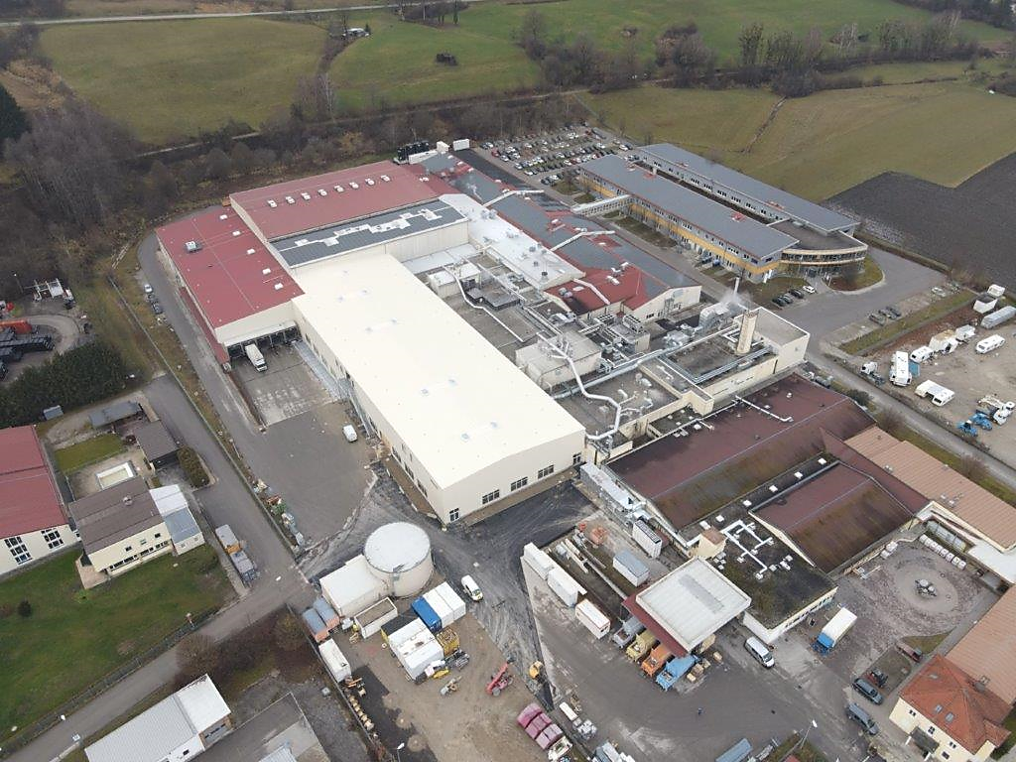

[Caption for Aenova_Site-Extension_Tittmoning_external-view.jpeg:]

With the construction of the new production building of around 3,100 sqm at the Aenova site in Tittmoning, capacities will be increased to up to 10 billion tablets. (Photo: Aenova).

**About the Aenova Group**

The Aenova Group is a leading global contract manufacturer and development service provider for the pharmaceutical and healthcare industries. As a one-stop shop, Aenova develops, produces and packages all common dosage forms, product groups and active ingredient classes of pharmaceuticals and food supplements for human and animal health: solid, semi-solid and liquid, sterile and non-sterile, high and low dose, OEB 1-5. With around 4,300 employees at 16 locations in Europe and the USA, Aenova generates annual sales of around 740 million euros[. www.aenova-group.com](http://www.aenova-group.com)

**Press contact:**

Dr. Susanne Knabe  
Head of Corporate Communication & PR

Aenova Holding GmbH

Berger Street 8-10

D-82319 Starnberg

Mobile: +49 170 22 368 42

Email: [susanne.knabe@aenova-group.com](mailto:susanne.knabe@aenova-group.com)