PRESS RELEASE

New chewable VegaGels® with algae-based omega-3 in multiple colours and flavours

- The new softgel capsules are based on the vegan Aenova VegaGels® and are filled with omega-3 DHA fatty acids from microalgae.
- The chewable vegan softgel capsule is easy to take.
- Available in Tutti-Frutti, Strawberry and Citrus flavours in a variety of colours, the DHA-rich supplement is particularly suitable for children.
- The new pure vegetable omega-3 softgel capsule is a joint project of AlaskOmega AG, Algarithm and Aenova.

Cornu, 23. September 2021 - With its VegaGels®, the Aenova Group, a global leading contract manufacturer and developer for the pharmaceutical and health care industries, has already been producing vegan softgel capsules based on seaweed extract for some time. Now the VegaGels® on a purely vegetable basis are being expanded to include a chewable variant.

In cooperation with AlaskOmega AG, the European subsidiary of Wiley Companies, and Algarithm, a leading Canadian company for algae DHA oils, Aenova manufactures the new vegan softgel capsules. These contain Algarithm's microalgae-based alphamega³ omega-3 DHA oil. The softgel capsules are chewable and therefore particularly easy to take. They are currently being produced specifically with children in mind. Flavours include Tutti-Frutti, Strawberry and Citrus Lemon with corresponding colours pink, red and yellow.

The new composition targets the needs of consumers who follow a vegetarian or vegan diet or prefer products without animal testing and are suitable for special religious food requirements, such as kosher or halal. The new softgel capsules are compliant with the regulations for the American, European and Chinese markets.

"We are delighted about this successful cooperation. It shows again that the Aenova Group is an innovative contract manufacturer that can adapt to customer requirements and market trends quickly and with flexible solutions," explains Michael Ammann, Head of the Softgel Capsules Business Unit at Aenova. "This also reflects the Aenova motto "Excellence beyond Manufacturing"!

The new chewable vegan softgel capsules with algae-based Omega-3 DHA will be introduced at the Vitafoods trade show in Geneva, October 5-7, 2021. Visit Aenova at Vitafoods at booth F60.

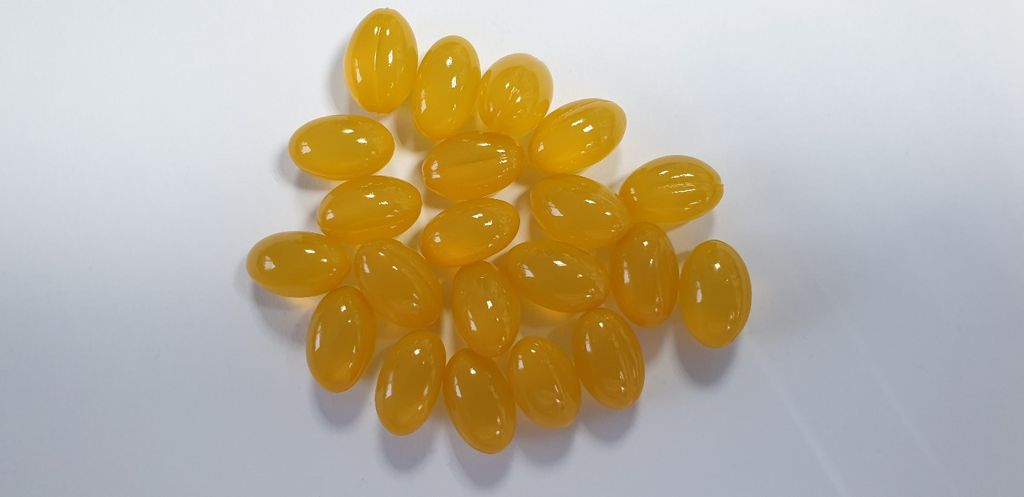

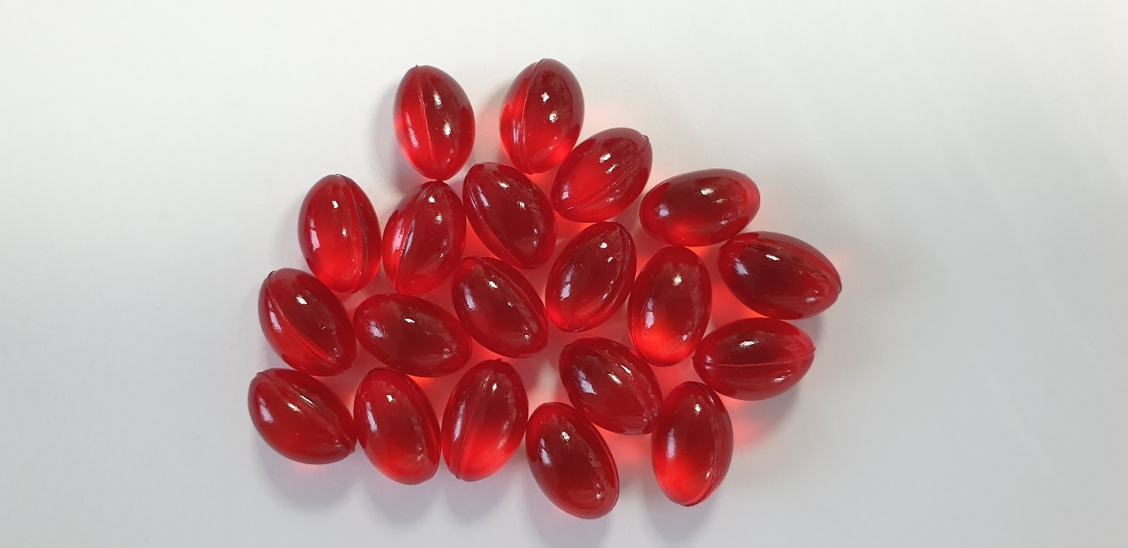
New chewable VegaGels® with algae-based omega-3 in multiple colours and flavours (Photos: Aenova)

About the Aenova Group

The Aenova Group is a leading global contract manufacturer and development service provider for the pharmaceutical and healthcare industries. As a one-stop shop, Aenova develops, produces and packages all common dosage forms, product groups and active ingredient classes of pharmaceuticals and food supplements for human and animal health: solid, semi-solid and liquid, sterile and non-sterile, high and low dose, OEB 1-5. With around 4,300 employees at 16 locations in Europe and the USA, Aenova generates annual sales of around 740 million euros. www.aenova-group.com

Press contact:

Dr. Susanne Knabe
Head of Corporate Communication & PR
Aenova Holding GmbH
Berger Straße 8-10
D-82319 Starnberg

Mobile: +49 170 22 368 42
Email: susanne.knabe@aenova-group.com

