PRESS RELEASE

**Aenova invests in new building for the production of highly potent drugs**

* **Aenova has laid the foundation stone for the new building for highly potent active ingredients at its Regensburg site.**
* **Highly potent drugs, especially against cancer, are produced in the new manufacturing facilities.**
* **With an investment of around 10 million euros, Aenova will thus be able to significantly increase production capacity to meet increased market demand.**

Regensburg, April 08, 2022 - Cytotoxics and cytostatics continue to experience increased demand in the global pharmaceutical market. To meet this growing demand, Aenova, global leading development service provider and contract manufacturer for the pharmaceutical and healthcare industries, is building a new facility at its Regensburg site. The investment of around €10 million will enable the company to significantly expand the production in the field of highly potent active ingredients and, in particular, cancer drugs. The foundation slab for the new building was poured in March 2022.

The Aenova site in Regensburg has been developing and producing tablets and capsules with highly potent active ingredients such as methotrexate, hydroxycarbamide, azathioprine, imatinib on the former von Heyden site since the 1950s. The new four-story building with a total building area of over 4,000 m² will include not only bulk production and packaging of highly potent drugs, but also the associated laboratories, development, warehouses and social rooms. This not only means a significant expansion of the production area and the so-called white areas of development and laboratory to over 300 m² at the Regensburg site. After the planned start of operations at the beginning of 2023, the manufacturing capacities can thus be increased in volume by significantly more than 1 billion tablets and capsules. An entire floor is also reserved for flexible customer requests for "on demand" production, so that existing as well as new customers can be individually supported in line with their requests.

"With this expansion, we are achieving our goal of strengthening the Regensburg site as the "Competence Center HPAPI & Oncology Products" within the Aenova Group," explains *Oliver Schmied*, Managing Director at the Aenova site in Regensburg. "After all, this will not only enable us to better serve market needs and customer requests, but above all to reliably provide essential medicines for patients suffering from cancer worldwide."

"Within the overall investments of the Aenova Group, the new building for highly potent active ingredients in Regensburg is an essential strategic building block. In line with our motto "Excellence beyond Manufacturing", we want to be a reliable and agile partner for our customers in key market segments," comments *Jan Kengelbach*, CEO of Aenova Group.

The new building is scheduled for completion in summer 2022 and occupation in fall 2022. This will be followed by the installation of the laboratories and the new "on-demand" GMP area. Additional customer orders can be produced from 2023.

**Image materia**l

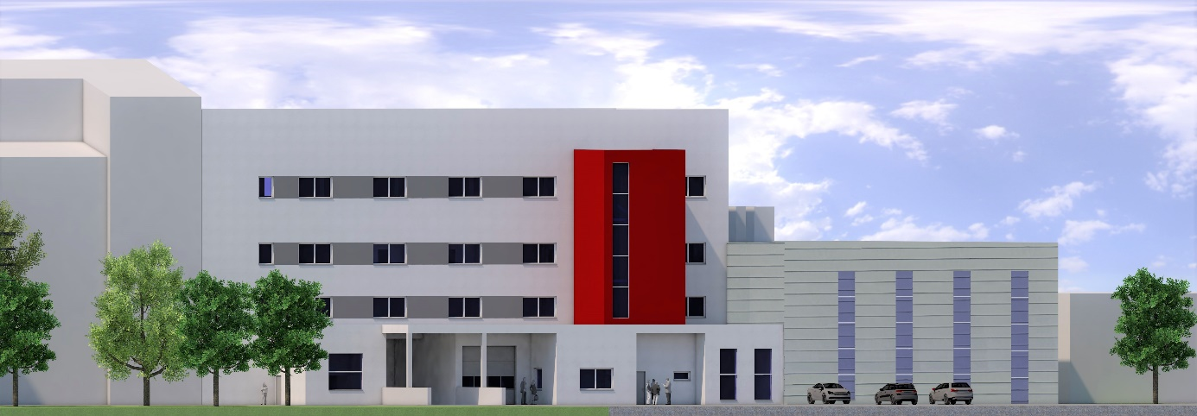

BU: Sketch of the new building at the Aenova site in Regensburg for the production of highly potent drugs (Sketch: Immo GmbH).

**About Aenova Group**

The Aenova Group is a leading global contract manufacturer and development service provider for the pharmaceutical and healthcare industry. As a one-stop store, Aenova develops, produces and packages all common dosage forms, product groups and active ingredient classes from pharmaceuticals to dietary supplements for human and animal health: solid, semi-solid and liquid, sterile and non-sterile, high and low dose, OEB 1 to 5 (Occupational Exposure Band). Around 4,200 employees at 16 sites in Europe and the USA contribute to Aenova's success. For more information, visit www.aenova-group.com.

**Press contact**

Dr. Susanne Knabe  
Head of Corporate Communication & PR

Aenova Holding GmbH

Berger Straße 8 - 10

D-82319 Starnberg

Mobile: +49 170 22 368 42

E-mail: [susanne.knabe@aenova-group.com](mailto:susanne.knabe@aenova-group.com)