PRESS RELEASE

One-stop shop for pharmaceutical and healthcare customers

CDMO Aenova presents investment strategy 2022 to 2025

- Aenova, global leading development services provider and contract manufacturer for the pharmaceutical and healthcare industries, presents its investment strategy for 2022 to 2025.
- The focus is on major investments to expand capacity in the area of solids, to expand capacity in the area of sterile technologies for prefilled syringes, fill & finish of vaccines and the processing of biologics, and to increase capacity for highly potent active ingredients up to OEB 5.
- Aenova thus strengthens, among others, the product areas sterile products, oncological preparations as well as hormones and biological active ingredients.
Starnberg, 02.03.2022 - Outstanding CDMOs (Contract Development & Manufacturing Organizations) not only offer their customers from the international pharmaceutical and healthcare industry quality and delivery reliability, but are also trusted partners throughout the life cycle of the product. This means anticipating market needs, offering flexible solutions and providing individual services.

Aenova is positioning itself with major investment projects in the years 2022 to 2025 precisely in this direction in order to be the partner of choice for its customers. The approximately 250 million euro investment package for the years 2022 to 2025 comprises various sub-projects. The focus is on significant capacity expansions for the areas of oncology and sterile manufacturing of biological active ingredients (particularly BSL1 and BSL2 vaccines) as well as in the area of high-volume standard solids. Specifically, these include:
- Expansion of production capacity for solid dosage forms at the Tittmoning site to up to 10 billion tablets per year. The new production building covering more than 3,100 square meters has been completed, the cleanroom interior has been finished and the production equipment has been brought in. The new building was commissioned in the fall of 2021.
- Massive expansion of capacities for solids production in the area of highly potent, cytotoxic products (up to OEB 5) at the Regensburg site. The foundation stone for the new building will be laid in the first quarter of 2022, and GMP-compliant production is planned for 2023.
- Capacity expansion at the semi-solida site in Carugate. A new high-speed liquid line will start up in the second quarter of 2022, followed by a new high-speed tubes line in 2023.
- Expansion of coating and bulk capacities for the production of oral solid dosage forms for penicillin production at the site in Latina, Italy, and massive capacity expansion for intramammary syringes in the Animal Health business.
- New sterile area for filling of biologics, prefilled syringes and fill&finish of vials with mRNA vaccines at the Latina site in Italy. The large facility will go into operation with a first customer project in the first quarter of 2022.
- Expansion of capacities for the sterile production of up to 100 million ampoules and vials per year at the Gronau site. The new line, now the sixth at the site, was commissioned in 2021.
- Capacity expansion in the production of high potent bulk for softgel capsules and expansion of packaging capacities at the Kirchberg site in Switzerland.
- Establishment of a Dry Powder Inhaler platform for several customer projects with planned launch in 2023 and 2024.

One-stop-shop for all common dosage forms and modern products
With this major investment program, Aenova is positioning itself as a future-oriented service partner for its customers across all 15 manufacturing sites. Through the three Business Units Solids, Semisolids & Liquids and Softgel Capsules, Aenova is placing itself as a one-stop store from development to scalable high-volume production and packaging services. A special customized offering is the "plant in plant" approach, where Aenova provides its customers with agile solution developments already in the first preliminary phase of a project. Specialized knowledge, such as on demanding release profiles or increased bioavailability, rounds out the offering profile.

Strengthening market position as leading CDMO
Under the motto "Excellence beyond Manufacturing", Aenova offers the highest quality at consistently high on-time delivery times. The majority of Aenova's sites have EU GMP or FDA and Anvisa approval. With the new investments, Aenova continues to evolve into a provider of differentiated technologies and development capabilities, both for small molecules and biologics. "With this holistic investment approach, we provide our customers with a future-proof technology portfolio, which is already positively reflected in many notable orders for the coming years. This strengthens Aenova's ambition to be among the top 5 CDMOs worldwide by 2025," explains Jan Kengelbach, CEO of Aenova.

Image material

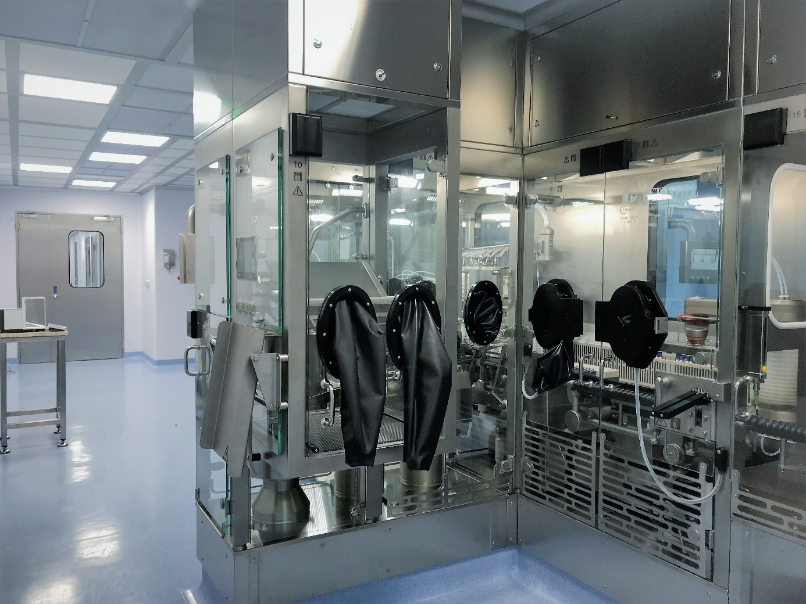
Caption: New sterile area for filling biologics at Aenova's Latina site. Photo: Aenova

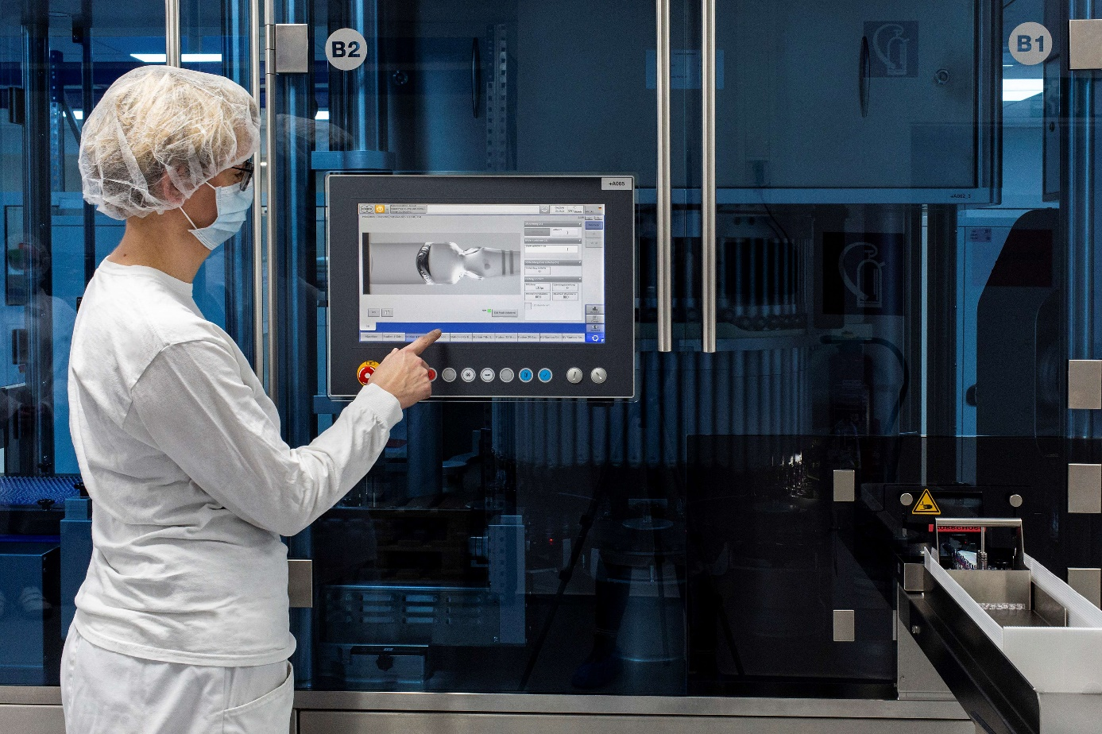
Caption: Operator starts fully automatic optical inspection in sterile production at Aenova's Gronau site. Photo: Aenova.


Caption: Aenova CEO Jan Kengelbach presents the investment strategy 2022 to 2025 of the Aenova Group. Photo: Aenova

About Aenova Group

The Aenova Group is a leading global contract manufacturer and development service provider for the pharmaceutical and healthcare industry. As a one-stop store, Aenova develops, produces and packages all common dosage forms, product groups and active ingredient classes from pharmaceuticals to dietary supplements for human and animal health: solid, semi-solid and liquid, sterile and non-sterile, high and low dose, OEB 1 to (Occupational Exposure Band). Approximately 4,300 employees at 16 sites in Europe and the U.S. contribute to the company's success. For more information, visit www.aenova-group.com.

Press contact

Dr. Susanne Knabe
Head of Corporate Communication & PR
Aenova Holding GmbH
Berger Straße - 810
D-82319 Starnberg

Mobile: +49 170 22 368 42
E-mail: susanne.knabe@aenova-group.com

