**PRESS RELEASE**

**New Probiotic softgel capsules support the health of the gut flora**

* **The new probiotic formulations are based on a dedicated shell combined with suitable fill mass enhancers.**
* **The new capsules are easy to swallow.**
* **The capsule content can be adapted to special needs and further ingredients.**
* **Taste, colour, and size are customizable.**

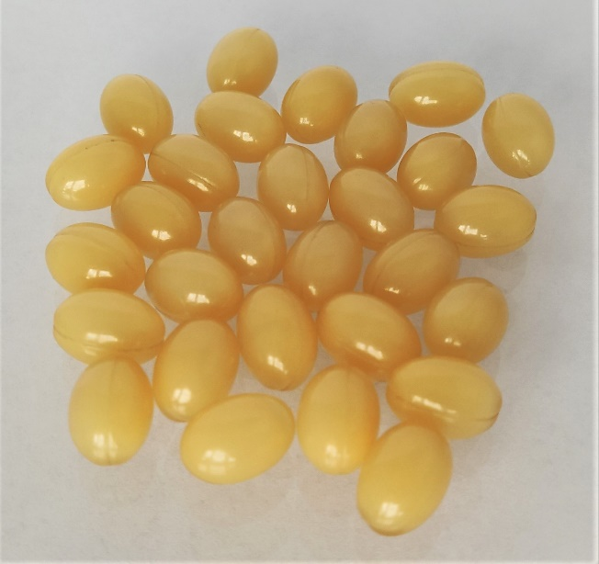Kirchberg, October 25, 2021 - With its probiotic softgel capsules, the Aenova Group, a global leading contract manufacturer and developer for the pharmaceutical and healthcare industries, has developed a new product for the wellbeing of the human body at its Swiss site in Kirchberg. The new capsules, which contain living bacteria or yeasts, do combine the advantages of the soft gelatin formulation technology with the health benefits of Probiotics.

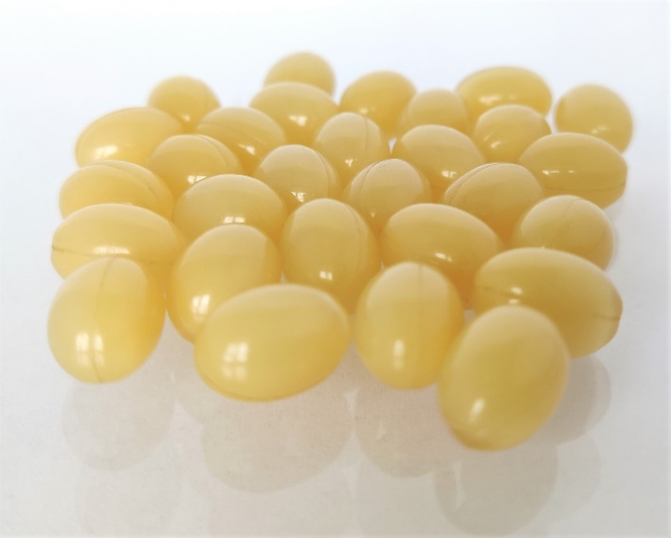(Photos: Aenova)

Probiotics help to restore the natural balance of bacteria in the gut when it has been disrupted by an illness or treatment. Some pathological conditions they can help with are irritable bowel syndrome, inflammatory bowel disease (IBD), infectious diarrhea (caused by viruses, bacteria, or parasites) or diarrhea caused by antibiotics.

The microorganisms, which are encapsulated under special conditions, do show activity and growth after production and storage. Therefore, viability of the contained “good” bacteria and yeasts is assured.

*Probiotic fill mass, T0. Left: 24h incubation; Right: 48h incubation* *(Picture: Aenova)*

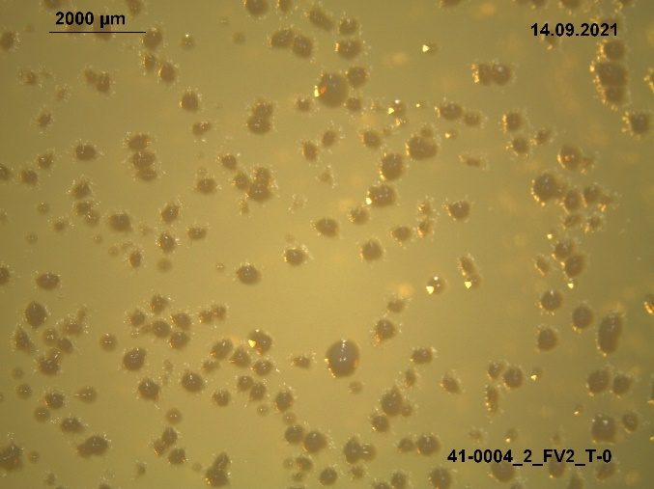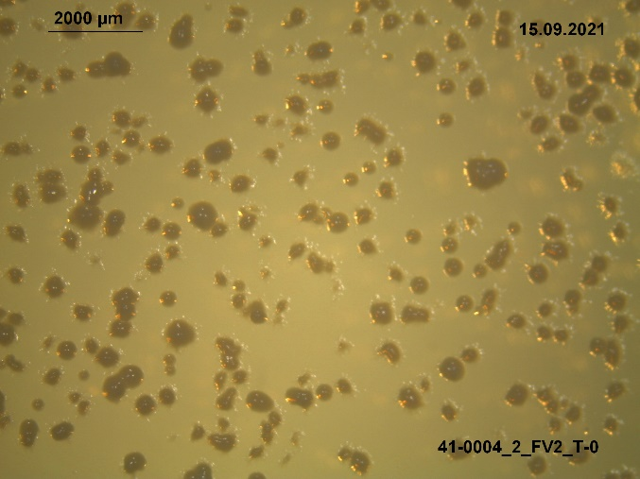

*Probiotic fill mass, T1. Left: 24h incubation; Right: 48h incubation (Picture: Aenova)*

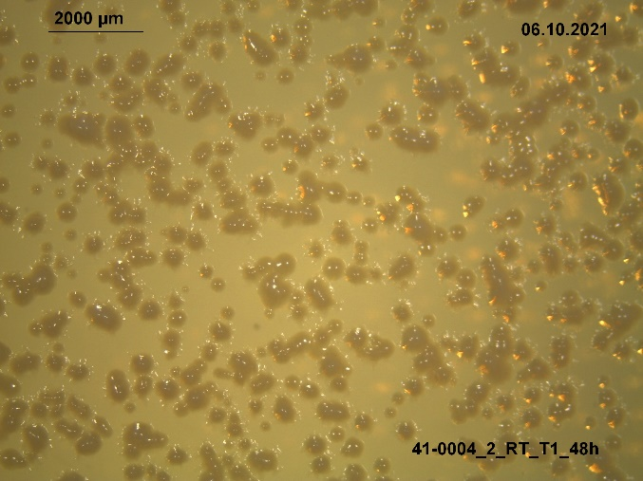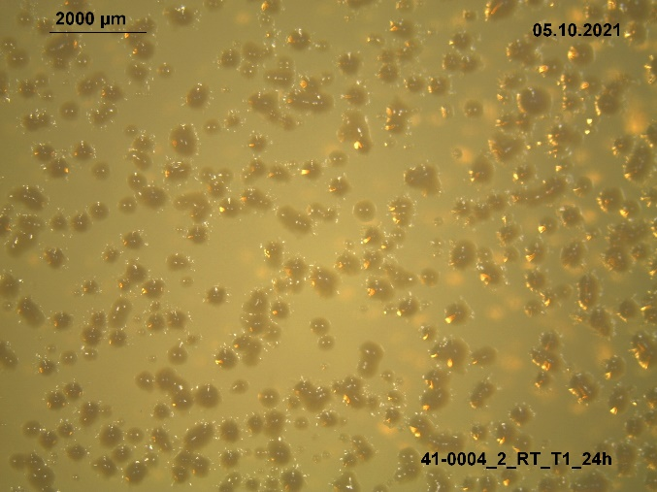

*Encapsulated probiotics, T0. Left: 24h incubation; Right: 48h incubation (Picture: Aenova)*

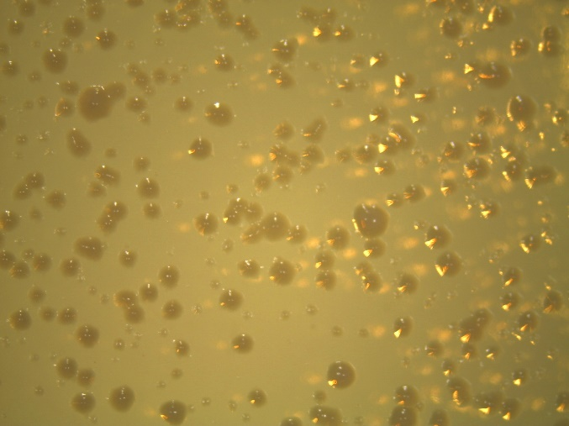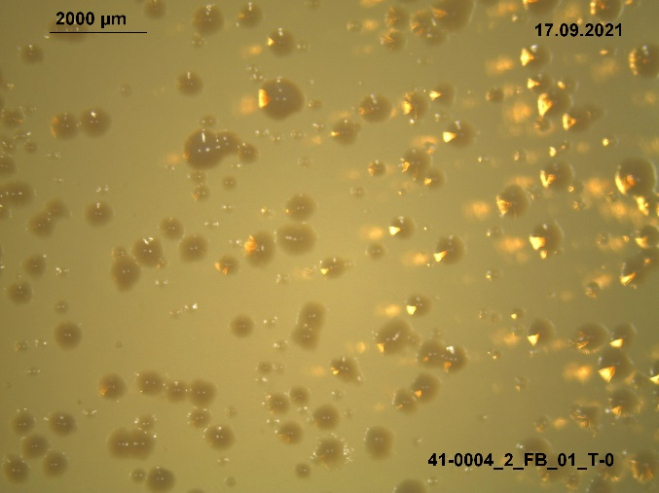

*Encapsulated probiotics, T1. Left: 24h incubation; Right: 48h incubation (Picture: Aenova)*

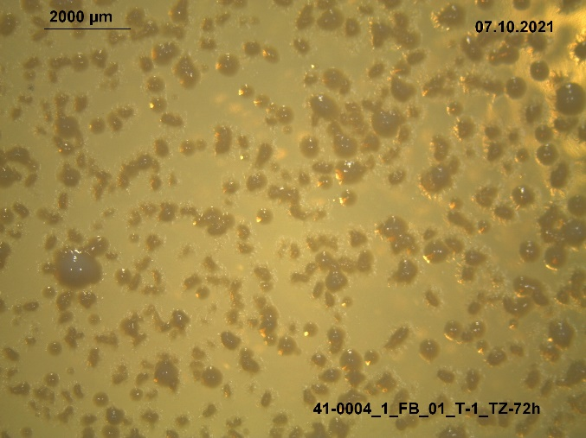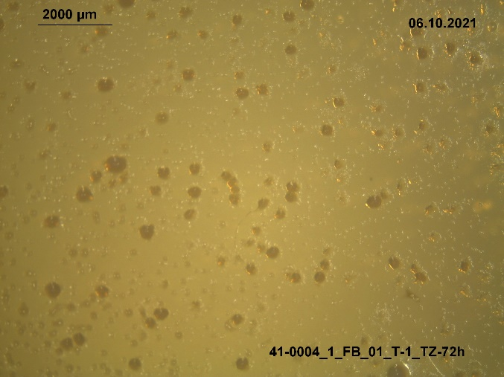

"Following our mission we pride ourselves on delivering innovative products and services to healthcare customers that improve and extend patients' lives”, states Dr. Christian Luftensteiner, Managing Director of Aenova’s Swiss site at Kirchberg. “In our Center of Excellence for soft capsules we apply decades of know-how and most modern infrastructure to provide impeccable quality to our customers worldwide.”

Visit Aenova at the CPhI trade show in Milan, November 9 – 11, 2021, booth 2C20, hall 2.

**About the Aenova Group**

The Aenova Group is a leading global contract manufacturer and development service provider for the pharmaceutical and healthcare industries. As a one-stop shop, Aenova develops, produces, and packages all common dosage forms, product groups and active ingredient classes of pharmaceuticals and food supplements for human and animal health: solid, semi-solid and liquid, sterile and non-sterile, high and low dose, OEB 1-5. With around 4,300 employees at 16 locations in Europe and the USA, Aenova generates annual sales of around 740 million euros[. www.aenova-group.com](http://www.aenova-group.com)

**Press contact:**

Dr. Susanne Knabe  
Head of Corporate Communication & PR

Aenova Holding GmbH

Berger Straße 8-10

D-82319 Starnberg

Mobile: +49 170 22 368 42

Email: [susanne.knabe@aenova-group.com](mailto:susanne.knabe@aenova-group.com)