PRESS RELEASE

Holistic sustainability strategy at Aenova:
the CO₂-free site in Sisseln (Switzerland)

- The Aenova site in Sisseln, Switzerland, stands for many years of tradition and special know-how, including in the production and packaging of moisture-sensitive solid dosage forms.
- A comprehensive sustainability strategy is pursued and this makes the site "CO₂-free".
- The environmental program is subject to an annual implementation check and thus continuously anchors sustainability in everyday work.
Sisseln, June 30, 2022 - In Sisseln, Switzerland, high-quality tablets, granules, effervescent tablets and hard capsules are produced by Aenova on a footprint of more than 6,000 m² and a production area of more than 1,900 m² by 160 employees - and with a completely CO₂-free energy supply by using electricity generated from hydropower. That´s 6 GWh per year of certified electricity from Swiss hydropower; this is supplemented by a photovoltaic system that covers around 8 to 10% of the site's energy requirements. In addition, heat is generated using a particularly smart approach: Process and comfort heat is obtained via heat exchangers as a by-product of the air compressors. As a result, the energy supply of the Aenova site in Sisseln is not only climate-neutral but completely CO₂-free. This protects the environment in the best possible way and reduces the consumption of natural resources. For more than ten years, the site has been ISO certified according to ISO 9001, ISO 14001, FSSC 22000 and OHSAS 18001/ISO 45001. In addition, all major projects are approved and supported by the Swiss Federal Office for the Environment.
Good for nature, good for employees
At the Sisseln site, a total of seven charging facilities for electric cars are available for use by employees at cost price. This service supports the switch to environmentally friendly mobility. And not just for Aenova employees - the plant's neighbors are also offered the use of the charging facilities at the same conditions. Another measure to reduce CO₂ emissions is the use of regional food in the site's canteen since the beginning of 2022, offering around 50% vegetarian dishes to also reduce the CO₂ footprint of food production and transport.
Measurable effects
The comprehensive sustainability concept at the Aenova site in Sisseln and its impact on the environment can be measured and demonstrably expressed in figures:
- 0 liters oil consumption
- 0 m³ Gas consumption
- 0.45 MWh electricity from solar energy
- 6 GWh of certified electricity from Swiss hydropower
- 4,744 km ridden by 16 employees as part of the "Bike to Work" campaign
- 90% LED illuminant
- 54 t per year Recycling (paper, plastic, metal, wood)

"Our holistic sustainability strategy and comprehensive sustainability management already make us proud," says Fridrik Thorsteinsson, Managing Director at the Sisseln site. "We are convinced that we can thus contribute to environmental protection in production as well as in everyday life. This is particularly sustainable because our colleagues are involved in the individual projects and can thus help shape and experience sustainability. This benefits the environment, nature as well as society in the region."
Jan Kengelbach, CEO of Aenova, adds: "We are investing around CHF 2 million in environmental protection measures here between 2020 and 2022. Such a commitment is important to us at the Aenova Group: because this is how we, as a company, make a local contribution to sustainability, and that is an essential investment in the future. In the overall sustainability strategy of Aenova, our site in Sisseln is exemplary. We also support comprehensive sustainability initiatives at the other Aenova sites on our way to CO₂ neutrality."

Image

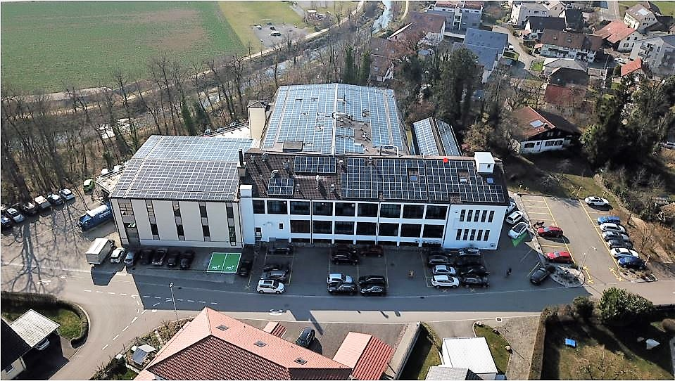
Caption: Large-scale photovoltaic systems are in operation on all roofs at the Sisseln site (Photo: Aenova)

About Aenova Group

The Aenova Group is a leading global contract manufacturer and development service provider for the pharmaceutical and healthcare industry. As a one-stop store, Aenova develops, produces and packages all common dosage forms, product groups and active ingredient classes from pharmaceuticals to dietary supplements for human and animal health: solid, semi-solid and liquid, sterile and non-sterile, high and low dose, OEB 1 to 5 (Occupational Exposure Band). Approximately 4,200 employees at 16 sites in Europe and the U.S. contribute to the company's success. For more information, visit www.aenova-group.com.

Press contact

Dr. Susanne Knabe
Head of Corporate Communication & PR
Aenova Holding GmbH
Berger Straße 8 - 10
D-82319 Starnberg

Mobile: +49 170 22 368 42
E-mail: susanne.knabe@aenova-group.com

